**Explanation about the http server implementation**

1. The code was developed on Intellij IDEA 2022.1.2(community edition)
2. It only provide very basic functionality.
3. I only ran some basic test from Safari like type “localhost:8080”
4. If user only type “localhost:8080”, the browser will redirect to “localhost:8080” actually, index.html will be displayed.

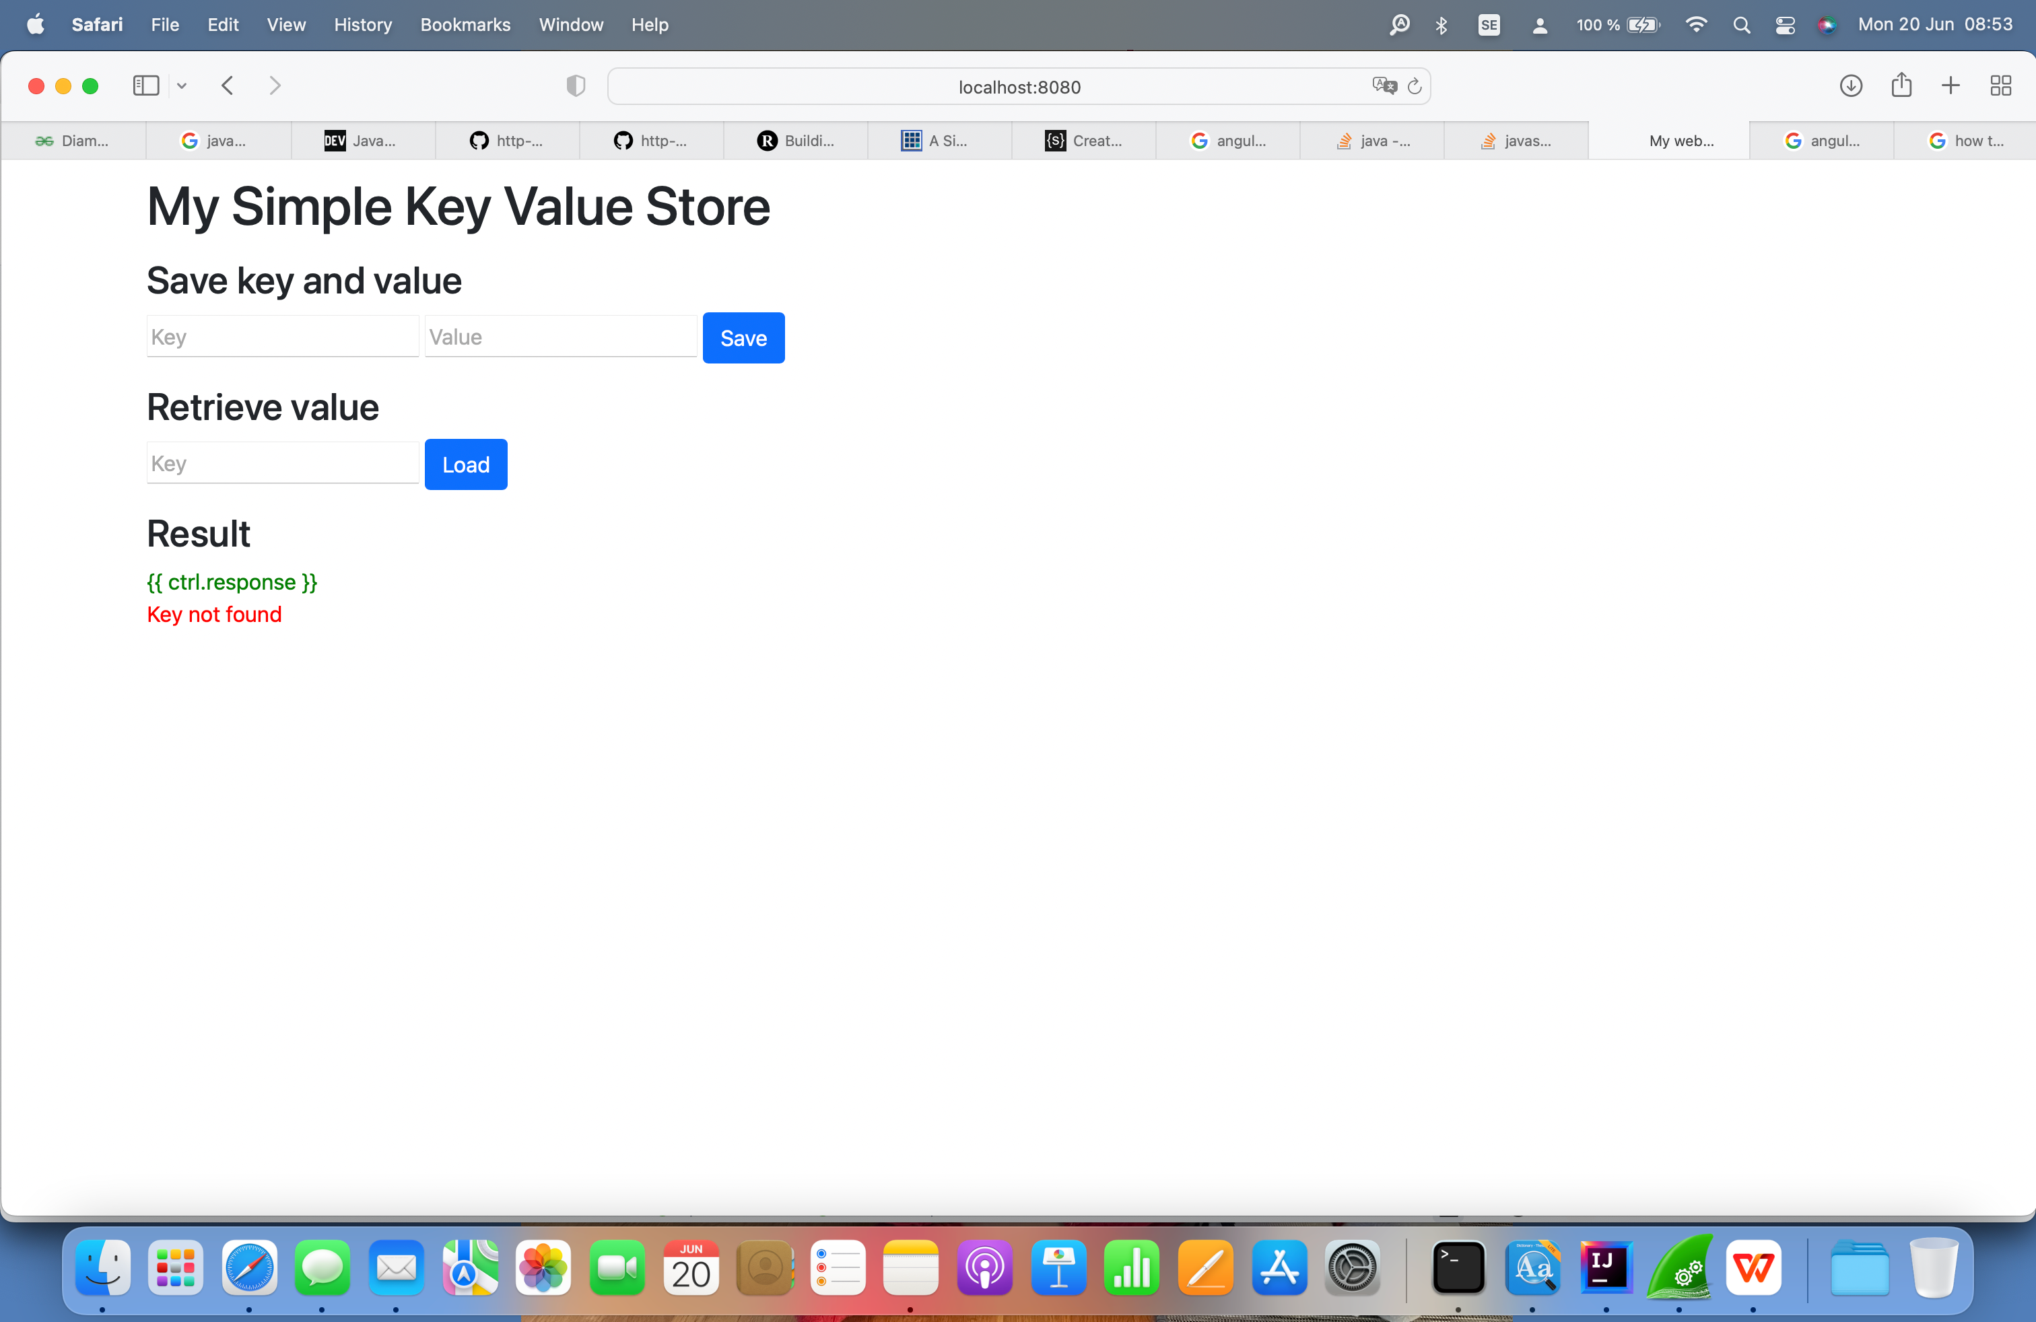

1. If you run “localhost:8080/test”, the following will be display
2. 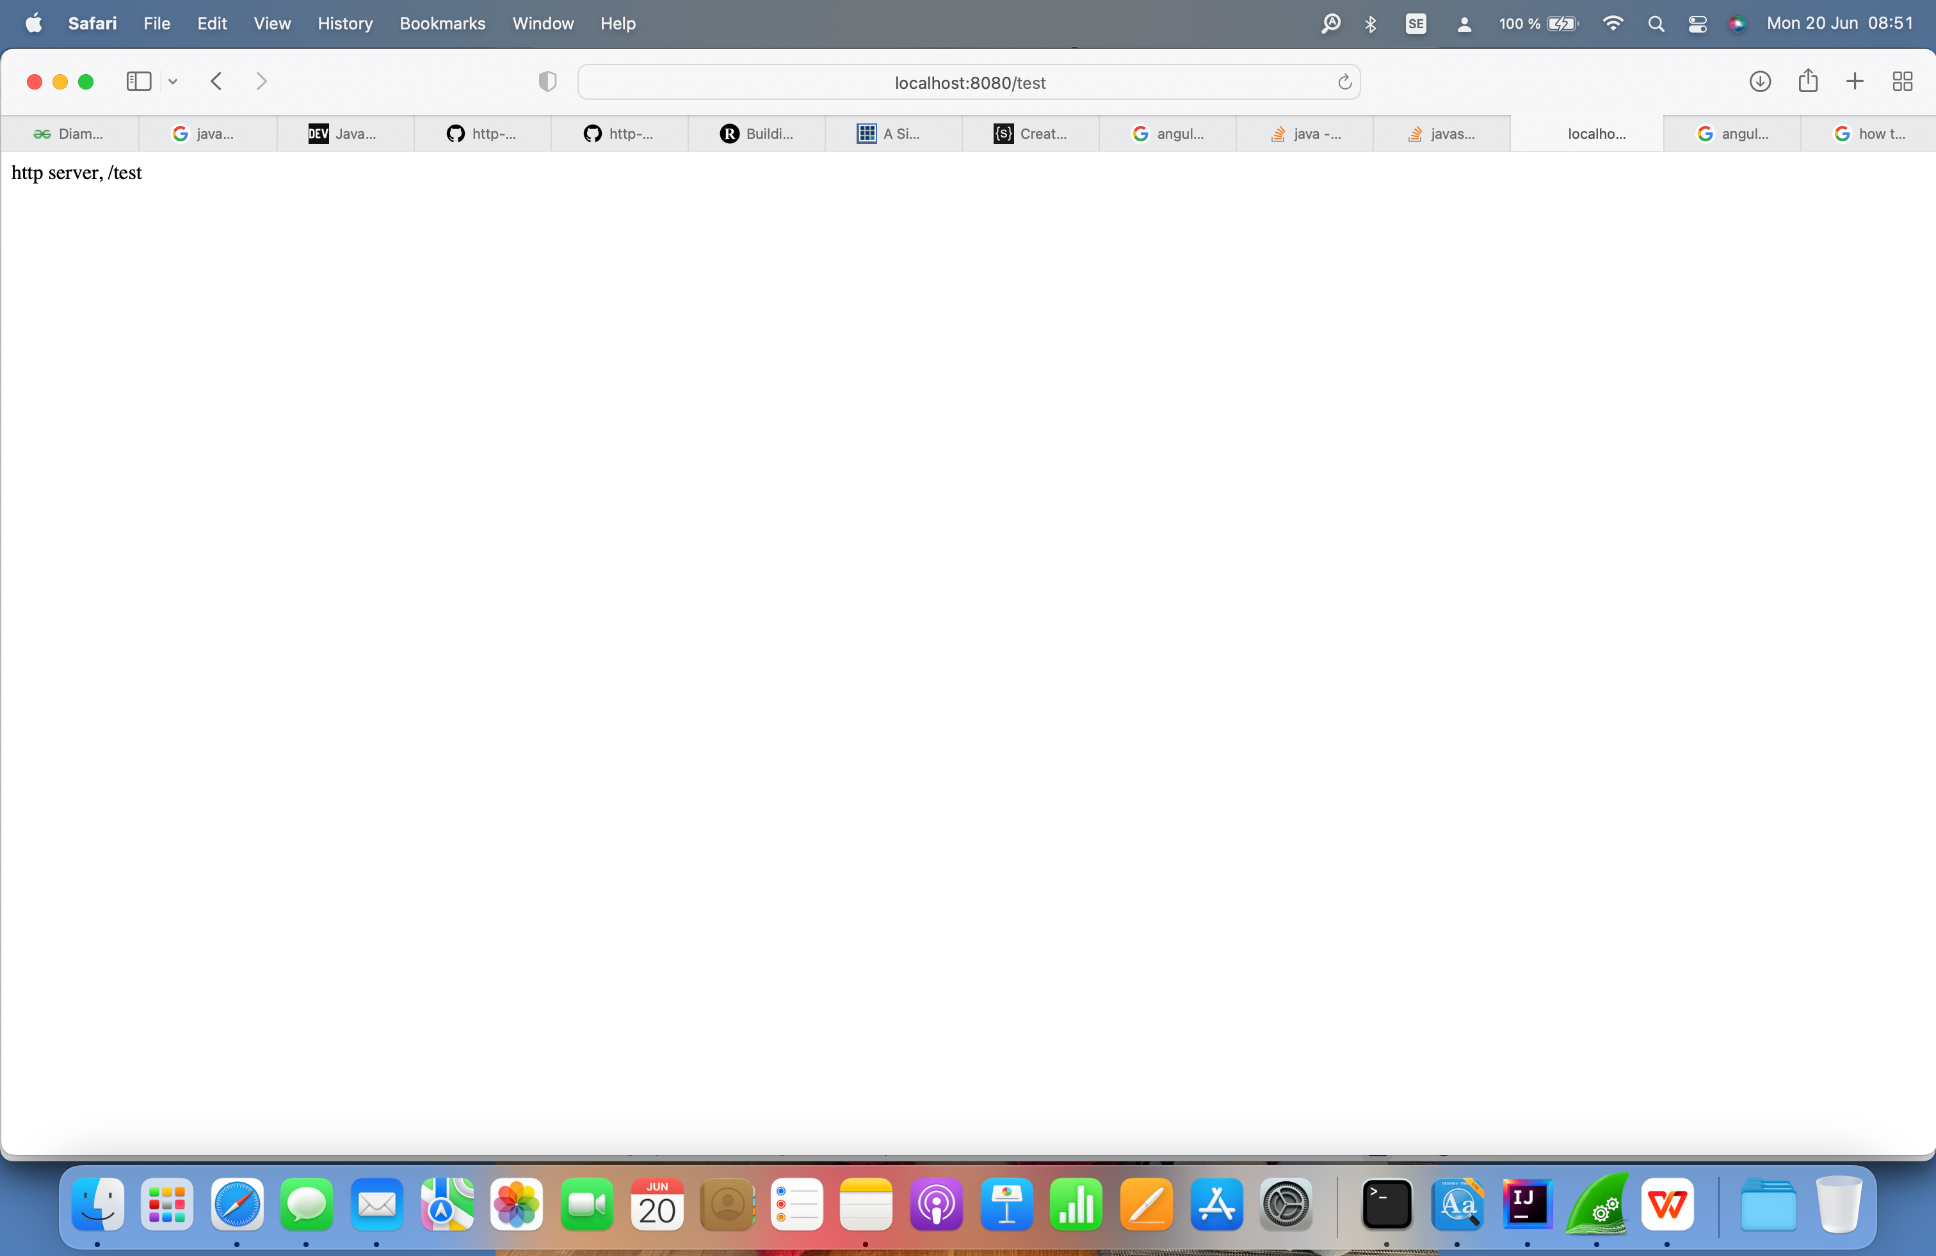
3. The current problem is if you save key and value, it doesn’t work. The post method is not working even I added post handler. I did not have time to figure out what is problem. I used Wireshark to grasp the package and found such issue:

If you type “localhost:8080” in browser, the default index.html will display, this is correct. Only one GET request is sent to server, but from the Wireshark capture, there is another “GET /js/controllers/main.js” request issued. Not sure why this javascript resourse requested. I know the main.js is responsble for the save key and value, retrieve value, post /api/data?key=xxx&value=xxx and get /api/data?key=xxx.

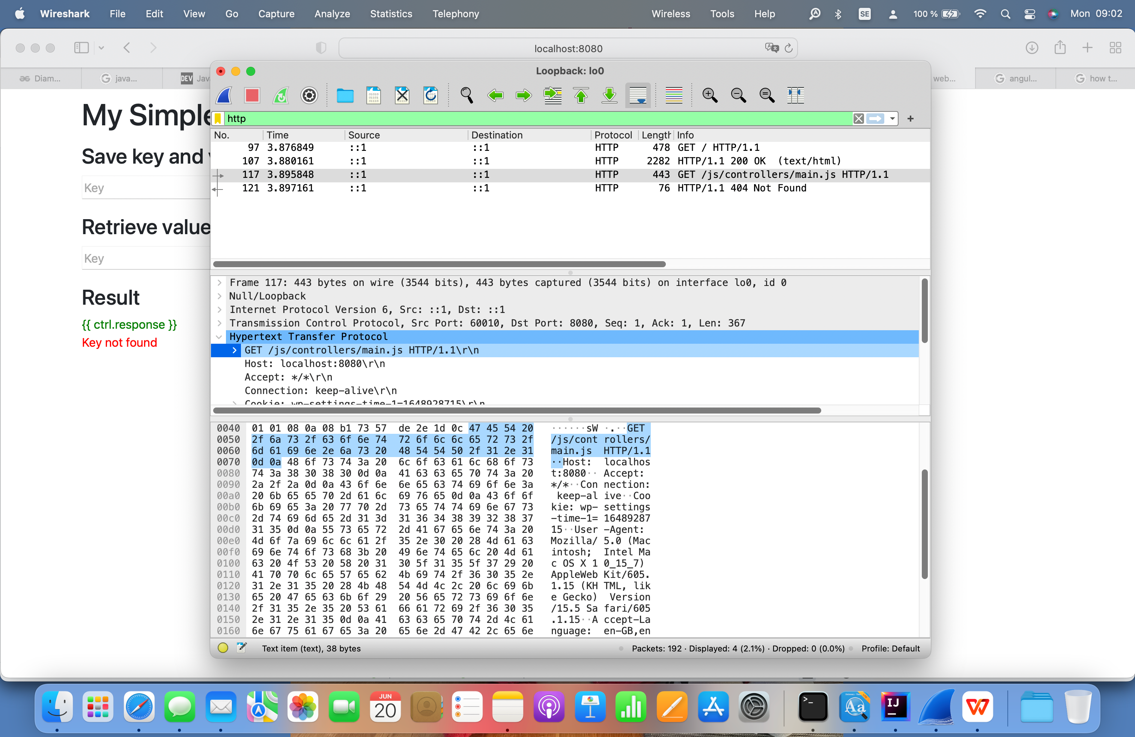

1. The http server is not perfect, still a lot of work needed to improve it. There are still some issues not fixed, but I do not want to spend so much time on it. Maybe in the future I can improve it in my spare time.